Project structure

SkillBridgebackend/

│ ├── Django_project/

│ ├── blog/

│ ├── media/

│ ├── migrations/

│ ├── myproject/

│ ├── newapp/

│ ├── staticfiles/

│ ├── db.sqlite3

│ ├── manage.py

│ ├── requirements.txt

│ ├── runtime.txt

│ ├── yolov5s.pt

│ └── yolov5su.pt

SkillBridgefrontend/

│ ├── public/

│ └── src/

├── .gitignore

├── README.md

├── package-lock.json

└── package.json

## ⚙️ Setup Instructions

```bash

# Backend setup

cd SkillBridgebackend

pip install -r requirements.txt

python manage.py migrate

python manage.py runserver

# Frontend setup

cd ../SkillBridgeFrontend

npm install

npm start

**Bugs and features needed**

|  |  |  |  |  |  |
| --- | --- | --- | --- | --- | --- |
| **Bug no** | **Title** | **Description** | **Expected**  **Result** | **Actual**  **Result** | **Status** |
| 1 | Login error message  Forget password | The login error message is vague (“Invalid credentials or something went wrong”) and doesn’t specify if the issue is a missing field, non-existent email, or incorrect password.  Forget password is not working, email is not sent, needs full fixes | System should display clear and specific error messages like: • "Email is required" • "Password is required" • "No account exists with this email" • "Incorrect password" | The error message always says “Invalid credentials or something went wrong.” | Incomplete |
| 2 | Registration error message | The error message “Registration failed. Please check your input.” doesn’t specify if the email already exists, fields are missing, or passwords don’t match. | Clear messages like: • "Email already in use" • "Required fields missing" • "Passwords do not match" | Always shows: “Registration failed. Please check your input.” | Incomplete |
|  |  | Admin bugs |  |  |  |
| 3 | Dashboard navbar has broken styling and non-functional notification icon | The dashboard navbar’s layout/styling is broken and inconsistent with the global navbar. Additionally, the notification icon is present but currently not functional (no dropdown or interaction). | Navbar should match global styling and the notification icon should show a dropdown or modal with notifications | Navbar layout is broken and notification icon does nothing | Incomplete |
| 4 | “Other” option in test creation doesn't prompt for custom input | When creating a test and selecting the “Other” option from a dropdown or radio list, the system does not ask the user to specify their preferred value | A new input field should appear asking the user to enter their custom option (e.g., “Please specify”) | Nothing happens; user cannot enter their custom value | Incomplete |
| 5 | Test difficulty selection doesn't trigger automatic question suggestions | In the test creation process, selecting a difficulty level (e.g., Easy, Medium, Hard) should automatically suggest relevant questions. Currently, nothing happens — the system does not respond to the difficulty choice. | Based on the selected difficulty, the system should auto-suggest a set of matching questions from the question bank | No automatic suggestions appear after selecting difficulty | Incomplete |
| 6 | Manual question creation missing difficulty level input | When manually adding questions during test creation, the form doesn’t ask for a difficulty level. This makes it impossible to categorize questions for future use in the question bank. | A difficulty level field (Easy, Medium, Hard) should be included when adding manual questions | Difficulty level input is missing | Incomplete |
| 7 | Imported questions do not include difficulty level | When importing questions (e.g., via PDF), there’s no way to assign a difficulty level. This prevents proper classification in the question bank. | Each imported question should allow assigning a difficulty level (or read it from file) | Difficulty data is missing from imported questions | Incomplete |
| 8 | Question import lacks CSV support | The system currently only allows importing questions via PDF format. CSV upload should also be supported for easier bulk uploads and structured input. | Both PDF and CSV formats should be supported for importing questions | Only PDF files are accepted | Incomplete |
| 9 | Question bank displays duplicate questions with identical answers | The question bank shows the same question multiple times if it has identical text and the same answer. This creates clutter and confusion for test creators. | Each unique question-answer pair should appear only once in the question bank | Duplicate entries are shown even when question and answer are identical | Incomplete |
| 10 | Time limit and marks per question should not accept values below 1 | In the test creation form, fields like Time Limit, Marks per Question, and Negative Marks allow values less than 1. These fields should require a minimum value of 1 to ensure valid test configuration. | System should restrict input to numbers **≥ 1** | Values below 1 are accepted and possibly saved | Incomplete |
| 11 | Test settings panel has unnecessary or unused options | The test settings section includes extra options that are either unused or not functional, leading to clutter and confusion for the user. | Only relevant, working settings should be visible | Several options are either unused, irrelevant, or not implemented | Incomplete |
| 12 | Test setting flaggings | Some test setting flags are not working | Flags should reflect  In test write page | Some are not working properly | Incomplete |
| 13 | Test publishing URL uses predictable UUID suffix | Although the test URL uses a UUID-like structure, the suffix is sequentially incremented (e.g., ...783e, ...783f, etc.), making it possible to guess other test URLs. This compromises security by exposing potentially restricted or private test links. | The UUID or token used in the test URL should be **truly random** and **cryptographically secure**, making it infeasible to guess | UUID suffix increments in a sequential pattern, making URLs guessable | Incomplete |
| 14 | Alignment issues on Test Instruction page | The layout of the test instruction page is misaligned. Elements such as instructions, icons, or buttons appear uneven or improperly spaced/styled. | All content should be well-aligned, with consistent spacing, padding, and visual structure | Misaligned or uneven layout elements reduce visual clarity and user experience | Incomplete |
| 15 | Face recognition & eye tracking too strict — needs sensitivity tuning and warning thresholds | The face recognition and eye tracking feature is overly sensitive, flagging normal user behavior as violations. There’s no system of graded warnings or categorization of malpractice. | System should allow for minor natural movements. Implement thresholds: e.g., one warning → soft alert, repeated behavior → serious malpractice flag | Immediate strict flagging for minor behavior, leading to false positives | Incomplete |
| 16 | Camera feed should be smaller and fixed position on screen | During proctored tests, the camera feed appears too large and floats inconsistently. It should be fixed to a corner (e.g., top-right) and be slightly smaller. | Camera feed should appear in a consistent, fixed position with smaller dimensions | Camera feed is large and not fixed, which obstructs the view or layout | Incomplete |
| 17 | No redirection or feedback page after test submission | After a user submits a test, the system does not redirect to a confirmation or "Thank You" page. It leaves the user uncertain. | User should be redirected to a confirmation or thank you page indicating successful submission | Test ends abruptly with no feedback, redirection, or confirmation | Incomplete |
| 18 | Next question logic should adapt based on current answer | The current system presents questions in a fixed sequence. However, for adaptive assessments, the next question should depend on the user’s response to the current one. | Based on whether the user answers correctly or incorrectly, the next question should adjust in difficulty or branch to a different flow | System follows a static sequence of questions regardless of correctness | Incomplete |
| 19 | Admin settings profile update does not show field-specific error messages | When updating admin profile settings, if a specific field has an issue (e.g., invalid email or missing name), the system shows a generic error instead of field-level validation. | The system should display error messages next to the exact fields causing the error | A generic error message is shown, giving no clue which field needs correction | Incomplete |
|  |  | **User Bugs** |  |  |  |
| 20 | All the test creation and manage test bugs and settings  same as admin bugs |  |  |  | incomplete |

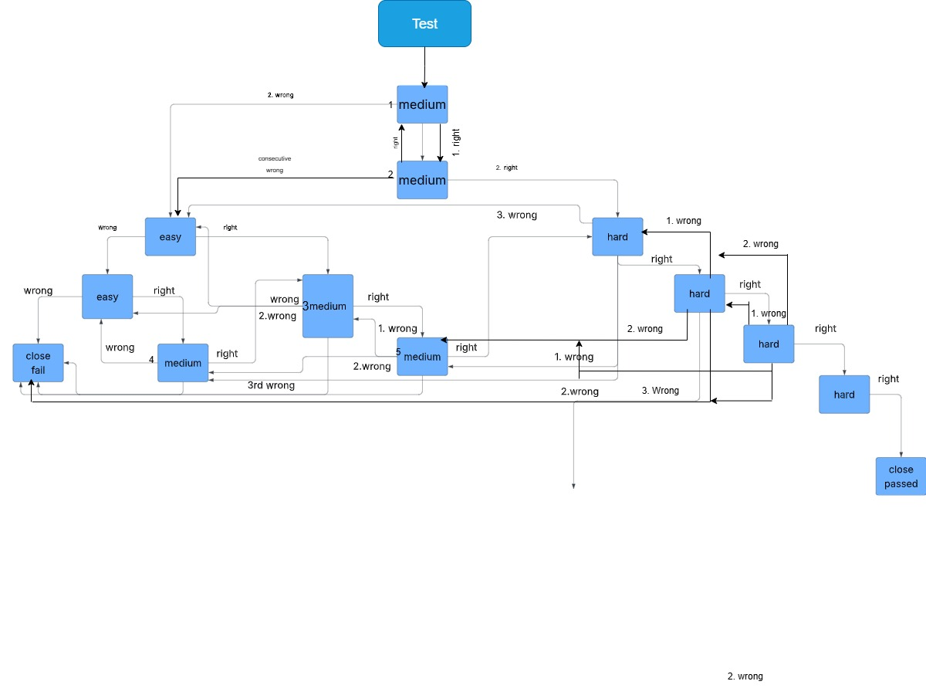

Example flow for test question producing(needs some refactoring)

And also refer test.txt to get some reference